Restorative justice in Education:
A conversation with Dr. Kathy Evans

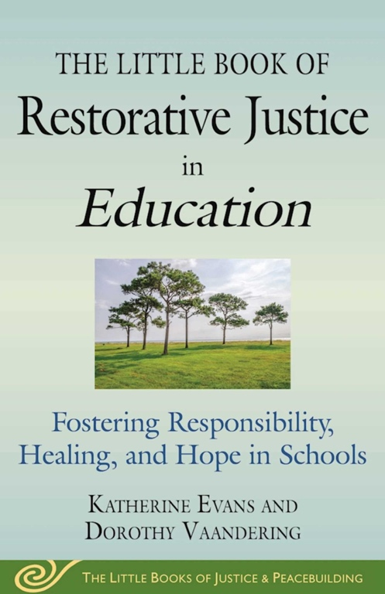

Conversation and book signing with educator and
co-author of The Little Book of Restorative Justice in Education

Monday, March 23, 2020
6pm-8:30pm
(6pm-6:30pm Refreshments)
St. John Baptist Church, Fellowship Hall
9055 Tamar Drive, Columbia, MD, 21045

RSVP
https://www.eventbrite.com/e/restorative-justice-in-education-a-conversation-with-kathy-evans-tickets-95108442913

Sponsored by Howard County Education Association; Howard County Public Schools System Office of Diversity, Equity, and Inclusion; and the Restorative Justice Partnership

